**Identification of Rotavirus Protein-Protein Interaction Interfaces By**

**Using Amino Acid Co-variation Analysis**

Travis Thompson

Virginia Tech Carilion School of Medicine and Research Institute

November 26, 2013

**Introduction**

Rotavirus (RV) is an enteric pathogen that can affect both adults and children, but is generally more severe in children. After inoculation, symptomatic infections present with nausea and vomiting for 2-3 days, which then progresses to watery diarrhea for another 4-5 days8. The non-inflammatory diarrhea leads to an isotonic dehydration and a metabolic acidosis. Eventual cardiovascular failure is the leading cause of death due to RV infection. Worldwide, RV is the most common cause of hospitalization for dehydration for infants and children. The infections start to occur at 6 months, which might be due to the decrease in passive maternal antibodies. All regions of the world are affected, but children in underdeveloped countries tend to have worse outcomes15. In the US, RV does not cause the mortality seen in underdeveloped areas but it still accounts for $319 million in direct healthcare costs annually8. In addition to infecting humans, RVs are found in nearly every other mammalian and avian species.

The RV virion is a non-enveloped, icosahedral virus with and eleven-segmented double-stranded (ds) RNA genome 16 (**Figure 1**). The virion has 3 protein layers that surround the inner gene segments. Each segment encodes one of the 6 structural proteins or one of the 6 nonstructural proteins. The 6 structural proteins are VP1, VP2, VP3, VP4, VP6, and VP7. VP4 and VP7 are the outer proteins and can induce neutralizing antibodies in an infected host. VP6 is the middle of the three protein layers and is the most common antibody target. VP2 is the inner most protein layer and interacts with VP6 and anchors enzymes VP1 and VP38. The interactions within and between VP2 and VP6 are well-characterized2,12. Specifically, the innermost core shell of the virion exhibits T=1 icosahedral symmetry and is comprised of 120 VP2 monomers, organized as 12 decameric units. The surrounding VP6 layer exhibits T=13 symmetry and is made up of 260 trimeric units of VP6 (780 monomers). VP6 engages VP2 at multiple contact points as visualized in the atomic-resolution structures of double-layered particles12. However, unlike VP6 and VP2, much less is known about protein-protein interactions between other viral proteins (e.g. VP2-VP1, VP2-VP3, and VP1-VP3).

RV virions can be classified based on different intrinsic aspects. Initially, the most common way was based on the antigenic properties of the exterior proteins (VP4 and VP7). However, this system gave little insight into the genetic diversity of circulating strains. A more recent classification system assigns a genotype to each gene based on established nucleotide percent identity cutoff values. The acronym Gx-P[x]-Ix-Rx-Cx-Mx-Ax-Nx-Tx-Ex-Hx is used to describe the genotypes of the VP7-VP4-VP6-VP1-VP2-VP3-NSP1-NSP2-NSP3-NSP4-NSP5/6 encoding segments7 (**Figure 2**). The implementation of this complete-genome classification system provided evidence that RV strains tend to maintain very specific and stable gene constellations (i.e., sets of genes). In particular, human RVs tend to have non-VP4/VP7 gene genotypes of either all genotype 1 or all genotype 2. While RV reassortants can be identified in nature, they are much less frequent than one might predict if genetic exchanges occurred freely with no negative consequences.

Indeed, given the natural capacity of RVs to reassort genes during co-infection, the obvious questions are: Why do these gene constellations exist? What are the restrictions on RV gene reassortment? One theory for why 'preferred' gene sets are seen among circulating strains is that the genes have functionally co-evolved. This co-evolution is thought to increase the level of fitness compared to when reassortment occurs, which mixes the genotype combinations14,3. I think that it is possible co-evolution could be happening at the protein level. In essence, viral proteins that interact during the replication cycle may have co-evolved to operate best when kept together4,13. This type of co-evolution is often supported by correlated amino acid mutation analysis (i.e., amino acid co-variation)4. In particular, amino acid co-variation has been widely used to infer functional interactions between different sites in a protein. Typically, a strong correlation between amino acid mutations is interpreted as evidence of functional interactions between proteins that are under substantial selection pressure. As such, my project goal was to identify amino acid residues of RV proteins that co-vary and determine if these residues are in areas of protein-protein interactions. I sought to analyze VP2 and VP6, two proteins that are known to interact in the viral capsid as a proof-of-principle for this approach (**Figure 1**). My hypothesis was that the areas of inter-molecular protein co-variation would be the same as those identified by known structural data as interaction sites for VP6 and VP2. If co-variant amino acids do indeed localize to sites of VP2-VP6 interactions, then this approach will be used to identify new interaction sites in less characterized proteins.

**Methods**

*Preparing RV VP2 and VP6 amino acid sequence alignments*

Nucleotide sequences of 115 RV VP2- and VP6-coding genes were individually downloaded from NCBI GenBank as FASTA files. Representative gene genotypes were chosen to create a balanced analysis that reflects the known level of RV diversity in nature (**Table 1**). Under-represented genotypes were identified using the NCBI BLAST and by careful analysis of the published literature11,10. Acquired nucleotide sequences were opened and organized using the Geneious Pro (v.5.6.5) software program6. The major open-reading frame (ORF) of each gene was identified based on previously determined start and stop codons. Thereafter, the ORF was computationally translated into an amino acid sequence for either the VP2 or VP6 protein. For analyzing inter-molecular co-variation, the amino acid sequences for the protein sets of each viral strain were concatenated (pasted back-to-back) with VP6 first, followed by VP2. Sequences were aligned using the Geneious alignment function with the cost matrix of Blosum62 and the default settings maintained (open gap penalty 12, gap extension penalty 3, and global alignment with free end gaps). Then, residues that created gaps in the alignment were removed. Due to extensive variation in both sequence and length, the first 100 amino acid positions of VP2 were removed. The three final alignments (i.e., VP2, VP6, and VP6-VP2) were saved in NEXUS format.

*Preparing VP2 and VP6 protein structure files*

Atomic coordinates of the RV double-layered particle structure12 were downloaded from the Protein Data Bank (3GZU), from which just the desired protein was isolated. The structure was opened and manipulated using the Chimera software program17. To prepare the VP2 protein structure file for co-variation analysis, all chains except A and B were computationally deleted. To prepare the VP6 protein structure file, all chains except chain C were deleted. These modified final structure files were saved in PDB format.

*Co-variation analysis using MISTIC*

Co-variation analysis was performed using the MISTIC server (http://mistic.leloir.org.ar/index.php )18. Trimmed, multi-sequence alignment NEXUS files were uploaded, and the RF strain of bovine RV was used as the reference. The prepared PDB files of either VP2 or VP6 were also uploaded. Under the advanced options, sequence clustering was selected, no identity for sequence clustering, low count correction was selected, there we no max fraction of gaps, and a reference sequence was used. The top 5% of co-varying residues identified by the program were mapped onto the protein structure(s) using the MISTIC interactive network function using the interactive network feature for both the VP6 and VP2 protein. For the VP6-VP2 co-variation, the locations in the top 5% residues that were not present in the VP6 or VP2 co-variation analysis (individually) were mapped onto the VP6 and VP2 proteins without the previously identified locations.

**Results**

*Choosing an amino acid co-variation program*

The goal of this project was to identify amino acid residues of RV proteins that co-vary (both intra- and inter-molecularly) and to determine if these residues are in areas of known protein-protein interactions. More specifically, I sought to determine whether amino-acid co-variation analysis could be used to identify novel protein-protein interaction sites. As proof-of-principle for this approach, I chose to analyze the co-variation within and between VP2 and VP6, two viral capsid proteins that intimately interact in the RV virion (**Figure 1**).

The first step in my project was to identify a robust, freely-available software program that would effectively identify amino acid variation using multi-sequence alignments. The first program I looked at was CAPS (Coevolution Analysis using Protein Sequences)5. This program was initially selected because it could be run on an external server. However, CAPs was inherently slow (the program took several days to run) and the results on initial trials were inconsistent. The second program selected was MSAvolve1 which seemed like it would be more useful because it had shown to be superior to many other methods of covariation analysis when using sample data. However, MSAvolve was ultimately impractical because it required the use and extensive knowledge of MatLab9, which itself requires programming knowledge and experience. Finally, I discovered MISTIC (Mutual Information Server to Infer Co-evolution), which is a is a web server for graphical representation of the information contained within a multiple sequence alignment and a complete analysis tool for Mutual Information (MI) networks in protein families18. The MISTIC program employs MI data to determine the co-evolution of the amino acids within the proteins. The server outputs a graphical visualization of several information-related quantities using a circos representation. This radial diagram provides an integrated view of the multi-sequence alignment in terms of (i) the MI between residue pairs, (ii) sequence conservation and (iii) the residue cumulative and proximity MI scores. Because MISTIC was the program that best suited our needs, it was chosen to analyze co-variation within and between VP2 and VP6.

*Identifying intra- and inter-molecular co-variation in VP2 and VP6 using MISTIC*

The VP2 and VP6 amino acid sequences chosen for co-variation analyses were those of genetically-diverse and population representative RV strains (**Table 1**). The sequences were collected and organized using GenBank and Geneious software programs as listed in the materials and methods section. The multiple sequence alignment files for either VP2 only (823 amino acids), VP6 only (397 amino acids in length), or VP6-VP2 (1220 amino acids in length) were then uploaded to the MISTIC web server, which identified areas of intra-molecular variation within VP6 and VP2 and then inter-molecularly for the VP6-VP2 combination.

**Figure 3** shows the results of the MISTIC analysis for the uploaded multi-sequence alignments, as presented using a radial diagram. Each individual amino acid residue of the protein is listed on the outside of the circle (residue based on bovine RV strain RF as reference). The next layer uses color to describe the level of conservation, with red representing highly conserved and blue representing lower conservation. The next 2 layers represent the cumulative MI and proximity MI respectively. In the center of the circle, connections with a MI score greater than 6.5 are shown. The top 5% of co-varying residues are shown in red, the 70-95% are shown in black, and the remaining are shown in gray18.

For the VP6-VP2 analysis, 5.8% of the residues were highly conserved. The VP6 only or VP2 only analyses revealed that 7.1% or 4.6% of residues, respectively, were highly conserved. The VP6 alignment had 36% amino acid co-variation overall, the VP2 alignment had 34% co-variation, and the VP6-VP2 alignment showed 35% co-variation. The results show that there are many areas of co-variation identified within each viral protein. The VP6 protein has 22 intra-molecular highly co-varying residues. The VP2 protein has 34 intra-molecular co-varying locations. The VP6-VP2 concatenated alignment had 64 co-variation locations, of which 8 were found to be unique, thus representing areas of inter-molecular co-variation between the two capsid proteins. The top 5% of co-varying amino acids found in all analyses are listed in **Table 2**.

The MI networks based on the co-variation analyses are shown as network diagrams in **Figure 4**. Each circle represents an amino acid location. The line connecting specific circles represents a significant MI value between the two positions. The color of the circles represents the level of conservation with red representing high conservation and blue representing low conservation. The VP6 only MI network has 2 main focuses of interaction. The VP2 only and VP6-VP2 MI networks both have 3 main focuses. All 3 figures show few points of conservation compared to the points of lower comparison. The localization to 2 or 3 network suggests that there are networks of higher interaction, though they are not exclusive and have contacts with the other groups. The high level of variation may have led to an increased level of MI.

*Three-dimensional locations of co-varying residues on the structures of VP6 and VP2*

Having identified intra- and inter-molecular co-varying residues within and between VP6 and VP2, the next step was to determine the three-dimensional (3D) location of these residues on the structure of the proteins (**Figure 5**). To do this, the known structure of the RV double-layered particle was downloaded to Chimera.12 Within the Chimera software program, the protein file could be manipulated. The solved crystal structure contains multiple copies of each protein, so the file was stripped of the extra copies so that only the VP6 or VP2 components (as monomers) remained. This restriction allowed manipulation of just one protein at a time, providing a clearer view of the location of the residues.

The top 5% of co-varying residues from the VP6 only and VP2 only analyses were mapped onto the 3D protein structure(s). Using the Interactive Network function of the MISTIC program, the locations were mapped and saved on the structure as a group. For VP6, the intra-molecularly co-varying regions were divided into two regions of the protein with an area between them where there were no identified highly co-varying residues. This polarity may be related to the MI network that shows two main regions of interaction (**Figure 4**). Given that the VP6 protein interacts with other VP6 proteins within the viral capsid (i.e., VP6-VP6 monomer contacts and VP6-VP6 trimer contacts), the polarity may be sites of interactions between VP6 molecules rather than intra-molecularly (i.e., within a single VP6 monomer). Several VP6-VP6 interaction points (residues 142-146, 353, and 380)12,2 were not predicted by MISTIC. However, some of the known VP6-VP6 interaction points (residues 32, 65, 68, 69, 70, 71) were flanked by positions (60 and 83) identified by this study (**Figure 5**). For VP2, I found that the location of the co-varying residues was more highly variable in distribution (**Figure 5**). The disperse co-varying areas might relate to the three focus MI map with more connections (**Figure 4**). The known 228 position of VP2 is close to 220, 221, 227, and 238; the 839 and 841 known VP2 locations is near the 832 and 837 identified locations; the 244 known VP2 locations is near the identified 238 and 250 locations; the 220 known location was identified directly and had 2 near locations at 221 and 227. So, though only one location was directly identified, there were many predicted locations that were within 15 amino acid locations from the known structure.

For the 5 unique VP6-VP2 co-varying residues, VP6 amino acid locations 199, 248, and 342 were identified and VP2 amino acid locations 116, and 711 were identified. When compared to the known structural interactions points between VP6 and VP2, the inter-molecular co-variation points were not structurally close to the known points or generally close on the protein structure.

**Discussion**

As with other segmented viruses (i.e., influenza viruses), the individual gene segments of RVs do not reassort randomly; yet, the reason(s) for the observed linkage disequilibrum is not known. It is possible that elective pressures act on particular RV segments, influencing them to stay together. Physical interactions of the encoded proteins may be one such reason for the existence of ‘preferred’ constellations of RV genes. Determining areas of proteins that co-vary could inform protein structure and interaction points. Showing that co-variation could predict structural contacts in known interactions would serve as a proof of principle to test other less characterized viral proteins. Understanding the evolutionary pressures on RV would help predict its mutations and regions of stability. Thus, co-variation analysis is expected to shed light on the replication strategies and evolutionary dynamics of these important pediatric gastrointestinal pathogens.

In this study, an evolutionarily-diverse group of RV VP6 and VP2 amino acid sequences were aligned and then analyzed for co-variation using a freely available web server called MISTIC. The co-variation data was then compared to known structural data to determine if it was able to predict the contact points. The VP6 and VP2 viral proteins were studied separately and together to determine intra- and inter-molecular co-variation. The results from this study showed that the intra-molecular co-variation analysis of VP2 provided some predictive value based on known contact points. The one amino acid location 220 was directly predicted. Moreover, the known contact points are closely flanked by positions predicted by the study (**Figure 5**). In contrast, the VP6 protein intra-molecular analysis did not show predictive value. The VP6-VP2 protein combination provided unique points that differed from the 2 proteins separately. These contact points were not substantiated from previous papers.

The results generated in the study have shown a low frequency of identifying the exact location of contact. However, it is important to not that the areas of known interaction were often flanked by locations identified by this study. It is possible that the areas of known interaction are so structurally necessary that any change in the amino acids at those locations will prevent the virus from forming and replicating effectively; thus they are highly conserved. The areas that are near these locations are likely less restricted in amino acid changes but still restricted by other parts of the protein, leading to the co-varying relationship. The areas of known interaction were based on studies showing that a mutation in those areas would prevent complete formation of the virus. It is possible that this study has identified areas of interaction that would not be obvious based on the structural data. In order to determine the full utility of the generated results, future biochemical and/or structural studies would need to be performed. If mutating individual locations without changing the locations with which the target location co-varies leads to changes in the structure of the viral proteins, there will be stronger support for the capacity of this type of bioinformatic analysis to predict structural relationships. There are also several locations identified that are not near the VP6-VP2 interaction points. Using the entire sequence, it was not possible to isolate only the VP2 and VP6 interactions, so the additional locations likely represent other structural interactions within with other viral proteins (i.e., VP1, VP3, NSP2 and NSP5).

In order to reduce the likelihood of error, the example data from the MISTIC paper was used to make sure the user was able to replicate the results and come to the same conclusion. It is possible that the MISTIC software could have misidentified areas of co-variance or left out areas that did co-vary based on the intrinsic aspects of the software algorithm. Since the program was not written specifically for RV, there is a possibility that the algorithm is ill suited for this particular dataset for unforeseen reasons. The data generated from this study is similar in presentation to the example dataset so it is unlikely that there were any significant errors in processing. The first 100 amino acids from the VP2 sequences were trimmed (removed) because of the high level of gaps and variability. While removing the gaps should have reduced the error, it may have also introduced other unknown changes that altered the results. A type 2 error could have occurred during the data analysis portion. Based on the proximity to known structural interaction, it is probable that the identified locations are significant; however, without further testing, there is still a reasonable chance that the identified locations do not represent true points of structural importance. Effort was made to have a representative sample for analysis shown by the phylogenetic tree analysis. A related possibility is that the majority of the strains in the dataset are virulent strains taken from symptomatic patients, which might ignore segments of the virus population that are also varying but missed because they are less virulent. A co-infection with multiple genetic types of RV could also be obscuring the true balance of the virus population. To address these possibilities, another genomic co-variation study is planned that will look only at the most prevalent viral type, the Wa type, to see if it is over represented in the co-variation analysis and obscuring co-variation in the less common types

Generating structural data from the interaction between VP6 and VP2 was a useful exercise to show that the concept was feasible. The real utility of the study would be to use it to study protein interactions where the crystal structures are difficult or unable to be studied. Being able to use bioinformatics data to help predict the location of protein interaction areas, if not specific loci, will help provide a target area when little is known about the structure. For example, the VP2 and VP1 interactions are not well elucidated. Using the sequence data to generate the co-variation analysis for the two proteins would help predict areas of structural interaction. That prediction could help direct crystallization attempts and targeted functional studies. This study did not directly predict known areas of interaction, but several of the identified locations were close to the known interactions. In an 800 amino acid sequence, being able to predict a location within around 10 amino acids or less would greatly reduce the amount of the protein that would need to be crystalized.

The results from this study have allowed us to now hypothesize that co-varying residues in RV proteins may be *near* sites of direct protein-protein interactions, but they themselves do comprise direct contact points. Nonetheless, testing this hypothesis will require further experimentation with mutating the sequences to see how it will affect the structure of the virus. The next steps for this project are to continue to verify the results of the study and to use MISTIC as a portion of other projects in the lab. Manipulating the RV sequences and then verifying any structural changes using biochemical analyses or crystallography is necessary for verification, but it is time and resource intensive and will need to be completed by another researcher. As mentioned above, isolating the Wa-like sequences and comparing the co-variation analysis with the varied population will help determine if there is too much influence by the Wa-like sequences in the analysis. Depending on the cost of sequencing, genomic analysis may benefit many other experiments in the lab when structural data is needed but the crystal structures are unavailable.

**References**

1. Ackerman SH, Tillier ER, Gatti DL. Accurate Simulation and Detection of Coevolution Signals in Multiple

Sequence Alignments. *PLoS ONE*. 2012;7(10):e47108.

2. Charpilienne A, Lepault J, Rey F, Cohen J. Identification of Rotavirus VP6 Residues Located at the Interface

with VP2 That Are Essential for Capsid Assembly and Transcriptase Activity. *J Virol*. 2002;76(15):7822–7831.

3. Codoñer FM, Fares MA, Elena SF. Adaptive Covariation between the Coat and Movement Proteins of Prunus

Necrotic Ringspot Virus. *J Virol*. 2006;80(12):5833–5840.

4. Donlin MJ, Szeto B, Gohara DW, Aurora R, Tavis JE. Genome-Wide Networks of Amino Acid Covariances Are

Common among Viruses. *J Virol*. 2012;86(6):3050–3063.

5. Fares MA, McNally D. CAPS: coevolution analysis using protein sequences. *Bioinformatics*. 2006;22(22):2821–

2822.

6. *Geneious Pro*. Biomatters Available at: http://www.geneious.com.

7. Heiman EM, McDonald SM, Barro M, Taraporewala ZF, Bar-Magen T, Patton JT. Group A Human Rotavirus

Genomics: Evidence that Gene Constellations Are Influenced by Viral Protein Interactions. *J Virol*.

2008;82(22):11106–11116.

8. Mandell GL, Bennett JE, Donlin R. *Mandell, Douglas, and Bennett’s Principles and Practice of Infectious*

*Diseases*. 7th Edition. Philadelphia, PA: Churchill Livingstone/Elsevier; 2010.

9. Matlab. *Version 7.10.0 (R2010a)*. Natick, Massachusetts: The Mathworks Inc.; 2010.

10. Matthijnssens J, Ciarlet M, Heiman E, et al. Full Genome-Based Classification of Rotaviruses Reveals a

Common Origin between Human Wa-Like and Porcine Rotavirus Strains and Human DS-1-Like and

Bovine Rotavirus Strains. *J Virol*. 2008;82(7):3204–3219.

11. Matthijnssens J, Ciarlet M, McDonald S, et al. Uniformity of rotavirus strain nomenclature proposed by the

Rotavirus Classification Working Group (RCWG). *Arch Virol*. 2011;156(8):1397–1413.

12. McClain B, Settembre E, Temple BRS, Bellamy AR, Harrison SC. X-ray Crystal Structure of the Rotavirus Inner

Capsid Particle at 3.8 Å Resolution. *J Mol Biol*. 2010;397(2):587–599.

13. McDonald SM, Davis K, McAllen JK, Spiro DJ, Patton JT. Intra-genotypic diversity of archival G4P[8] human

rotaviruses from Washington, DC. *Infect Genet Evol*. 2011;11(7):1586–1594.

14. McDonald SM, Matthijnssens J, McAllen JK, et al. Evolutionary Dynamics of Human Rotaviruses: Balancing

Reassortment with Preferred Genome Constellations. *PLoS Pathog*. 2009;5(10):e1000634.

15. Parashar, U.D., et al. Rotavirus and sever childhood diarrhea. *Emerg Infect Dis*. 2006;12(2):304–6.

16. Pasevento JB, et al. Rotavirus proteins: structure and assembly. *Curr Top Microbiol Immunol*.

2006;(309):189–219.

17. Pettersen EF, Goddard TD, Huang CC, et al. UCSF Chimera—A visualization system for exploratory research

and analysis. *J Comput Chem*. 2004;25(13):1605–1612.

18. Simonetti FL, Teppa E, Chernomoretz A, Nielsen M, Marino Buslje C. MISTIC: mutual information server to

infer coevolution. *Nucleic Acids Res*. 2013;41(W1):W8–W14.

**Figures and Tables:**

**Figure 1.** Schematic of the RV Virion, dsRNA Genome, and Gene Genotypes Rotavirus Triple Layer Particle showing the structural proteins VP2, VP4, VP6, and VP7. Used with Permission by McDonald, S.A.

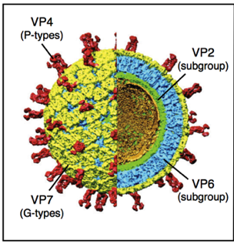

**Figure 2.** Schematic of Dominant Human RV Genogroups and Reassortment Patterns

Group 1 describes the Wa-like (genogroup1) and Group 2 describes the DS-1 (genogroup 2), both of which are common genetic patterns. Though coinfected, there are few instances where the two genomes combine to have proteins from type 1 and 2 genogroups (center example).

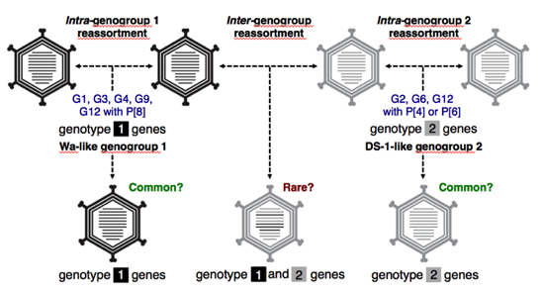

**Table 1: Rotavirus Strain Name with Sequence Accession Numbers**

Strain name in column 1 is paired with the accession numbers for the VP6 protein (column 3) and VP2 protein (column 4) retrieved from GenBank. The G/P-type of the strain is listed when available. There are 115 strains total.

|  |  |  |  |
| --- | --- | --- | --- |
| Column1 | Column2 | Column3 | Column4 |
| Common Strain Name | G/P-type | VP6 | VP2 |
| 6361 (hu) | G1P[8] | I1-HQ609561 | C1-HQ609555 |
| 61060 (hu) | G1P[8] | I1-HQ609563 | C1-HQ609557 |
| BE00036 (hu) | G1P[8] | I1-HQ392316 | C1-HQ392318 |
| BE00029 (hu) | G1P[8] | I1-HQ392237 | C1-HQ392242 |
| Wa (hu) | G1P[8] | I1-FJ423118 | C1-FJ423114 |
| KU (hu) | G1P[8] | I1-AB022768 | C1-AB022766 |
| Dhaka16-03 (hu) | G1P[8] | I1-DQ492673 | C1-DQ492670 |
| D (hu) | G1P[8] | I1-EF583024 | C1-EF583022 |
| AM06-I (hu) | G1P[8] | I1-EU984108 | C1-EU984104 |
| DS-1 (hu) | G2P[4] | I2-EF583028 | C2-EF583026 |
| RV3 (hu) | G3P[6] | I1-FJ998275 | C1-FJ998271 |
| 2008747332 (hu) | G3P[8] | I1-HM773694 | C1-HM773690 |
| 2008747336 (hu) | G3P[8] | I1-HM773683 | C1-HM773679 |
| DC140 (hu) | G3P[8] | I1-FJ947743 | C1-FJ947739 |
| DC2102 (hu) | G3P[8] | I1-FJ947831 | C1-FJ947827 |
| DC2262 (hu) | G3P[8] | I1-FJ947875 | C1-FJ947871 |
| DC1563(hu) | G3P[8] | I1-FJ947180 | C1-FJ947176 |
| DC5549 (hu) | G3P[8] | I1-FJ947521 | C1-FJ947517 |
| P (hu) | G3P[8] | I1-EF583040 | C1-EF583038 |
| YO (hu) | G3P[8] | I1-DQ870500 | C1-DQ870498 |
| R479 (hu) | G4P[6] | I1-DQ873675 | C1-GU189552 |
| ST3 (hu) | G4P[6] | I1-EF583048 | C1-EF583046 |
| Gottfried (po) | G4P[6] | I1-D00326 | C1-GU199487 |
| Hosokawa (po) | G4P[8] | I1-DQ870492 | C1-DQ870490 |
| OSU (po) | G5P[7] | I5-AF317123 | C1-GU199515 |
| IAL28 (hu) | G5P[8] | I1EF583032 | C1-EF583030 |
| KJ25-1 (bo) | G8P[7] | I5-HM988972 | C1-HM988959 |
| B3458 (hu) | G9P[8] | I2-DQ870504 | C1-DQ870502 |
| Wi61(hu) | G9P[8] | I1-EF583052 | C1-EF583050 |
| 116E (hu) | G9P[11] | I1-FJ361206 | C1-FJ361202 |
| YM (po) | G11P[7] | I5-X69487 | C1-GU199516 |
| Matlab36-02 (hu) | G11P[8] | I1-GU199507 | C1-GU199504 |
| Dhaka6 (hu) | G11P[25] | I1-GU199521 | C1-GU199519 |
| KTM368 (hu) | G11P[25] | I12-GU199496 | C1-GU199493 |
| Dhaka12-03 (hu) | G12P[6] | I1-DQ146664 | C1-DQ146661 |
| Matlab13-03 (hu) | G12P[6] | I1-DQ146675 | C1-DQ146672 |
| GER172-08 (hu) | G12P[6] | I1-FJ747629 | C1-FJ747626 |
| RU172 (po) | G12P[7] | I5-DQ204741 | C1-GU199192 |
| GER126-08 (hu) | G12P[8] | I1-FJ747617 | C1-FJ747614 |
| B4633-03 (hu) | G12P[8] | I1-DQ146642 | C1-DQ146639 |
| Dhaka25-02 (hu) | G12P[8] | I1-DQ146653 | C1-DQ146650 |
| TB-Chen (hu) | G2P[4] | AY787645 | AY787652 |
| S2 (hu) | G2P[4] | Y00437 | DQ870486 |
| B1711 (hu) | G6P[6] | EF554086 | EF554083 |
| DRC86 (hu) | G8P[6] | DQ005115S07 | DQ005115S10 |
| DRC88 (hu) | G8P[8] | DQ005104S07 | DQ005104S10 |
| 69M (hu) | G8P[10] | EF583016 | EF583014 |
| L26 | G12P[4] | DQ146695 | EF583034 |
| N26-02 | G12P[6] | DQ146686 | DQ146683 |
| RV176-00 | G12P[6] | DQ490555 | DQ490552 |
| RV161-00 | G12P[6] | DQ490549 | DQ490546 |
| Au-1 | G3P[9] | DQ490538 | DQ490536 |
| T152 | G12P[9] | DQ146702 | DQ146700 |
| B4106 | G3P[14] | AY740737 | AY740740 |
| Se584 | G6P[9] | EF583044 | EF583042 |
| Hun5 | G6P[14] | EF554108 | EF554105 |
| MG6 | G6P[14] | EF554097 | EF554094 |
| PA169 | G6P[14] | EF554130 | EF554127 |
| 111/05-27 | G6P[14] | EF554141 | EF554138 |
| B10925-97 | G6P[14] | EF554119 | EF554116 |
| A64 | G10P[14] | EF583020 | EF583018 |
| NCDV-Lincoln | G5P[5] | AF317127 | DQ870494 |
| BRV033 | G6P[1] | AF317126 | EF560613 |
| RF | G6P[1] | K02254 | X14057 |
| Uk | G6P[5] | JF693064 | JF693060 |
| WC3 | G6P[5] | AF411322 | EF560616 |
| PO-13 | G18P[17] | D16329 | AB009630 |
| A131 | G3P[7] | AF317124 | EF560619 |
| A253 | G11P[7] | AF317122 | EF560622 |
| SA11-5S | G3P[1] | DQ838647 | DQ838632 |
| SA11-30/19 | G3P[1] | DQ838648 | DQ838633 |
| SA11-H96 | G3P[5] | DQ838650 | DQ838635 |
| SA11-30/1A | G3P[1] | DQ838649 | DQ838634 |
| RRV | G3P[3] | EF583009 | EF583007 |
| TUCH | G3P[24] | EF583013 | EF583011 |
| SA11-5N | G3P[1] | DQ838646 | DQ838631 |
| OVR762 | G8P[14] | EF554152 | EF554149 |
| 30-96 | G3P[14] | DQ205226 | DQ205222 |
| L338 | G13P[18] | JF712559 | JF712556 |
| ETD_822 | G16P[16] | GQ479952 | GQ479948 |
| Lamb-NT | G10P[15] | FJ031028 | FJ031025 |
| *02V0002G3* | G19P[30] | FJ169858 | *FJ169854* |
| KE4852 | G25P[26] | GU983675 | GU983673 |
| B10 | G3P[2] | HM627557 | HM627554 |
| Azuk-1 | G21P[29] | AB573082 | AB573080 |
| Chubut | G8P[14] | FJ347104 | FJ347101 |
| E30 | G3P[12] | JF712570 | JF712567 |
| Dai-10 | G24P[33] | AB573073 | AB573071 |
| 0613158 | G1P[8] | EU984108 | EU984104 |
| MMC6 | G2P[4] | HQ641358 | HQ641356 |
| MMC88 | G2P[4] | HQ641367 | HQ641365 |
| HCR3A | G3P[3] | EU708905 | EU708902 |
| Cat97 | G3P[3] | EU708949 | EU708946 |
| CU-1 | G3P[3] | EU708916 | EU708913 |
| DC5544 | G3P[8] | FJ947510 | FJ947506 |
| BA222 | G3P[9] | GU827410 | GU827407 |
| PAH136 | G3P[9] | GU296428 | GU296422 |
| PAI58 | G3P[9] | GU296429 | GU296423 |
| GO34 | G6P[1] | GU937881 | GU937878 |
| BP1879 | G6P[14] | FN665682 | FN665678 |
| Rio_Negro | G8P[1] | FJ347126 | FJ347123 |
| PTRV | G8P[1] | FJ422136 | FJ422132 |
| GER1H-09 | G8P[4] | GQ414544 | GQ414541 |
| BP1062 | G8P[14] | FN665693 | FN665689 |
| E403 | G14P[12] | JF712581 | JF712578 |
| B383 | G15P[11] | FJ347115 | FJ347112 |
| DQ-75 | G10P[11] | GU384194 | GU384191 |
| CH-1 |  | GU188283 | HQ641294 |
| A79-10 | G3P[3] | EU708938 | EU708935 |
| K9 |  | EU708927 | EU708924 |
| E3198 | G3P[3] | JX036369 | JX036366 |
| DC706 | G9P[8] | JF521466 | JF521462 |
| G2275 | G9P[8] | JF521477 | JF521473 |
| D205 |  | JF304919 | JF304916 |
| AK26 |  | JF304930 | JF304927 |
| PA260-97 | G3P[3] | HQ661116 | HQ661113 |

**Figure 3 (A-C): Radial Covariation Diagram**

Sequence position and amino acid are listed on the periphery (residue based on bovine RV strain RF as reference). The next layer describes the level of conservation, with red representing highly conserved and blue representing lower conservation. The next 2 layers represent the cumulative MI and proximity MI respectively. In the center of the circle, connections with a MI score greater than 6.5 are shown. The top 5% of co-varying residues are shown in red, the 70-95% are shown in black, and the remaining are shown in gray18 Figure 2A is VP6, Figure 2B is VP2, and Figure 2C is the VP6VP2 concatenation.

*3A. VP6*

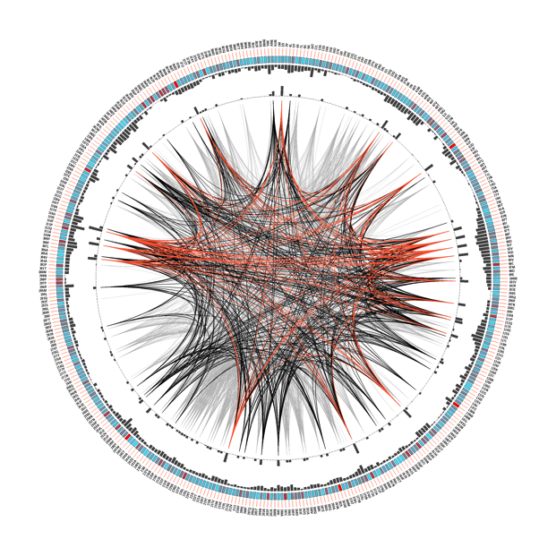

*3B. VP2*

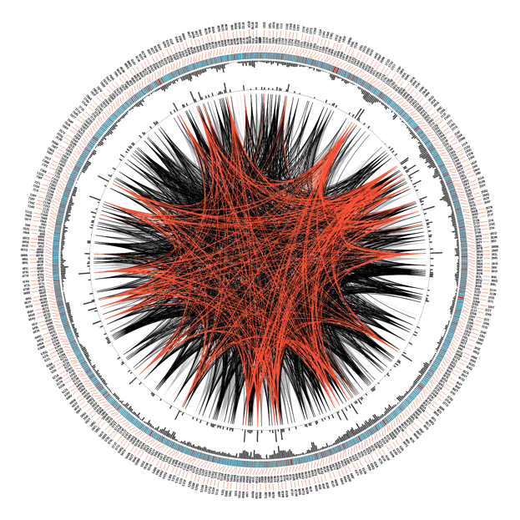

**3C. VP6VP2**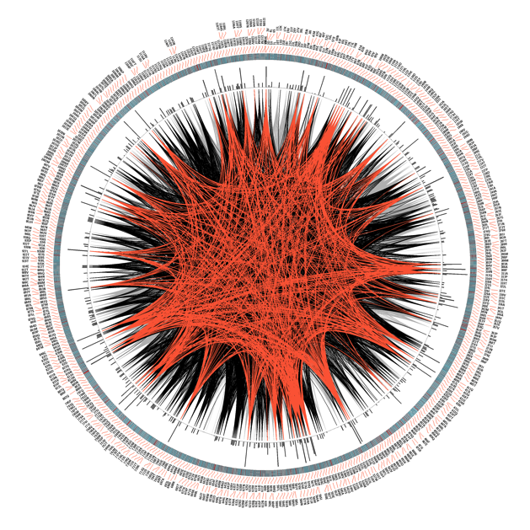

**Figure 4 (A-C). Mutual Information (MI) Networks for VP6, VP2, and VP6VP2 combined proteins.**

Each circle represents an amino acid location. The line connecting specific circles represents a significant MI value between the two positions. The color of the circles represents the level of conservation of the amino acid position within the sequence; red represents highly conserved and blue represents less conserved locations. Parts A, B, and C represent VP6, VP2, and VP6VP2 respectively.

*Figure 5A: VP6 Network Diagram*

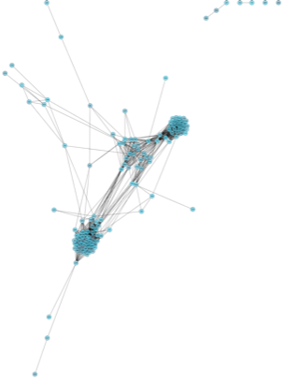

*Figure 5B: VP2 Network Diagram*

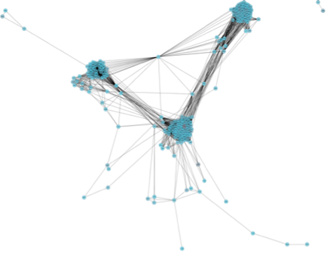

*Figure 5C: VP6VP2 Network Diagram*

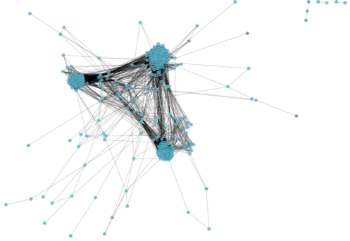

**Table 2. Intra-molecular and Intermolecular Covariation (Top 5%)**

The table shows the sequence location of intra-molecular interactions within VP6 and VP2 in the left 2 columns predicted by the covariation analysis. The right 2 columns show the sequence location of the inter-molecular interactions between VP6 and VP2 that were unique to the concatenated protein and not identified in the intra-molecular analysis. The values used represent the top 5% of the mutual information values for each protein.

|  |  |  |  |
| --- | --- | --- | --- |
| Intra-molecular | | Inter-molecular | |
| **VP6** | **VP2** | **VP6** | **VP2** |
| 2D | 103S | 199I | 116A |
| 39I | 120T | 248Y | 711Q |
| 45E | 173V | 342M |  |
| 60N | 175T |  |  |
| 83N | 220A |  |  |
| 86D | 221V |  |  |
| 89V | 227E |  |  |
| 92V | 231R |  |  |
| 101V | 238V |  |  |
| 109I | 250Y |  |  |
| 114D | 258Q |  |  |
| 115S | 268D |  |  |
| 120S | 290R |  |  |
| 151T | 368T |  |  |
| 172A | 414V |  |  |
| 217V | 420I |  |  |
| 305A | 428Q |  |  |
| 310N | 432V |  |  |
| 315E | 475V |  |  |
| 339S | 479Q |  |  |
| 348S | 492V |  |  |
| 369D | 501H |  |  |
|  | 551A |  |  |
|  | 591A |  |  |
|  | 640A |  |  |
|  | 650H |  |  |
|  | 655A |  |  |
|  | 676V |  |  |
|  | 690D |  |  |
|  | 720Y |  |  |
|  | 730F |  |  |
|  | 745A |  |  |
|  | 818V |  |  |
|  | 832Q |  |  |
|  | 837N |  |  |
|  | 857F |  |  |
|  | 869V |  |  |

**Figure 5 (A-C). Protein Structure of VP6, VP2 and VP6 with VP2 with Covariation Analysis**

These figures show the respective proteins as isolated from the DLP in Chimera. The locations on the proteins that were predicted by the covariation analysis are highlighted in blue. The location of known interaction between VP6 and VP2 are highlighted in red. Areas of known VP6-VP6 interaction are highlighted in green. The interaction location that was predicted by the covariation analysis (VP2 220) is highlighted purple.

*Figure 5A. VP6 Protein Structure*



*Figure 5B. VP2 Protein Structure*

*Figure 5C. VP6VP2 Combined Protein Structure*

